**LEBANESE AMERICAN UNIVERSITY**

**USAID – HIGHER EDUCATION SCHOLARSHIP PROGRAM**

**HES - Volunteering Program Verification Form**

This form is to be used to document volunteering hours. If a student volunteers for multiple organizations, a separate form must be used for each organization. **This form must be turned in by the 28th of each month, the latest.**

I certify that the scholar Amal khaled al rajab completed a total of 8 hours of service at Life Sculptor.

The hours were completed hours as per the below:

Hours # 2 (date) _02/09 - 06/09_ (initials of supervisor) __A.K.___

Hours # 2 (date) _09/09 – 13/09_ (initials of supervisor) __A.K.___

Hours # 2 date) _16/09 – 20/09 (initials of supervisor) __A.K.___

Hours # 2 date) _23/09 – 27/09 (initials of supervisor) __A.K.___

Brief description of the activities the scholar performed or participated in:

Amal acquired a new position which is supervisor for the PowerPoint Will and Wellness club where she received a tasks and distribute them to the students to finish them .

Written feedback about the scholar’s performance:

Amal has taken on the role of supervisor for the PowerPoint team in the Well and Wellness Club. In this position, she effectively receives tasks and distributes them among students, ensuring that projects are completed efficiently. Her leadership is essential for maintaining workflow and supporting team members in their assignments.

Please rate the overall performance of the scholar at your organization:

|  |  |  |  |
| --- | --- | --- | --- |
|  | Mastery (5) | Proficient (3) | Emerging (1) |
| **Problem solver** | X |  |  |
| **Engaged & Committed** | X |  |  |
| **Open-minded & multicultural** | X |  |  |

Signature

& stamp

__________________________

_

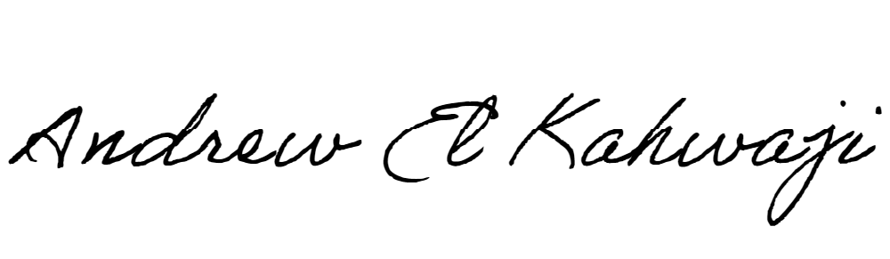

Printed Name _Andrew El Kahwaji_

Date __25/09/2024___

Email __andrew.lifesculptor.coo@gmail.com __

Phone __+961 71 914 378__

**LEBANESE AMERICAN UNIVERSITY**

**USAID – HIGHER EDUCATION SCHOLARSHIP PROGRAM**

